uArm-Firmware Guidance

|  |  |  |
| --- | --- | --- |
|  | Firmware 3.2 | Firmware 4.3 |
| Description | Old Version Firmware | Add port automatic identification, fix some bugs |
| Blockly | √ | √ |
| Control | √ | √ |
| Teach & Play | √ | √ |
| Leap Motion | - | √ |
| Draw/Laser | √ | √ |
| 3D Printing | √ | - |
| APP Control | √ | - |
| Support  Grove Modules | √ | - |

Note: the above conditions based on uArm Studio Version 1.1.20.

Q: How to switch between firmware 3.2.0 and 4.3.0 ?

A: If you want to switch the firmware from 3.2.0 to 4.3.0, simply press the “flash firmware V4.2.1” button, then it will flash automatically, and vice versa.

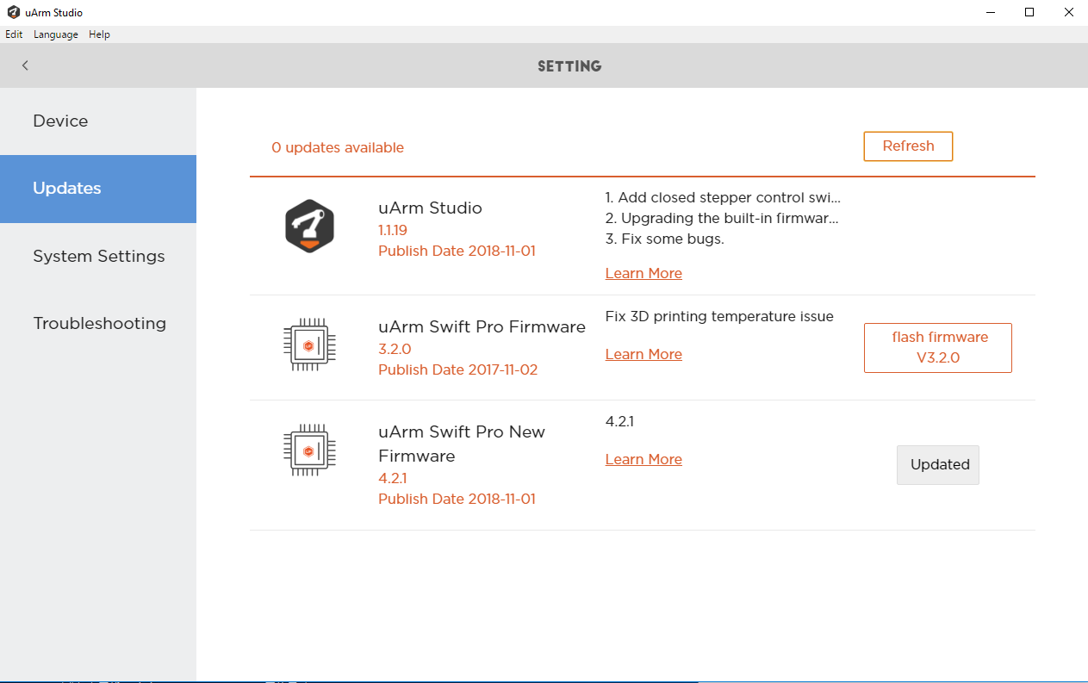

Q: How to use uArm Studio with different firmware?

A: Connect the uArm to your computer, available functions will be shown on uArm Studio automatically.

Q：What firmware is compatible with the vision camera kit?

A：There is a particular firmware for the vision camera kit, please click [here](https://github.com/TonyLeheng/Vision-Pick-and-Place) to download the file [UArmSwiftPro_2ndUART.hex].

Q：How to flash the vision camera kit firmware?

A：

1. Connect the uArm to your computer;
2. Download the [XLoader](http://xloader.russemotto.com/XLoader.zip) and [firmware](https://github.com/TonyLeheng/Vision-Pick-and-Place);
3. Open XLoader, select the firmware (hex file);
4. Click “Device”, select “Mega(ATMEGA2560)”;
5. Click “COM port”, select port (the port is different for each computer, please open the “Device Manager” and check the “Ports(COM&LPT)” beforehand);

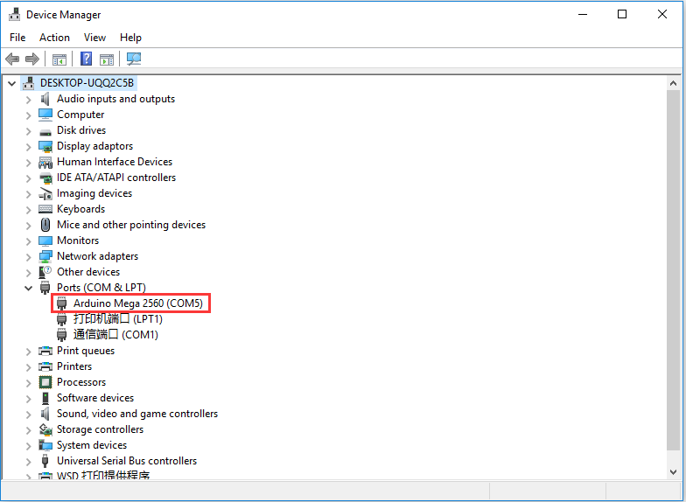

1. Set “Baud rate” as 115200; Click “Upload” to finish the flashing process.

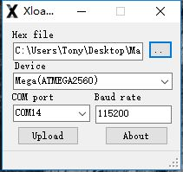

**Note**: Before you use xLoader to flash the firmware, please make sure you check the following steps:

1) Firstly, turn off the software (e.g. Arduino IDE and/or uArm Studio);

2) After that, enter into “Task Manager” (Ctrl+Shift+Esc), and turn off the “uarmcore”.

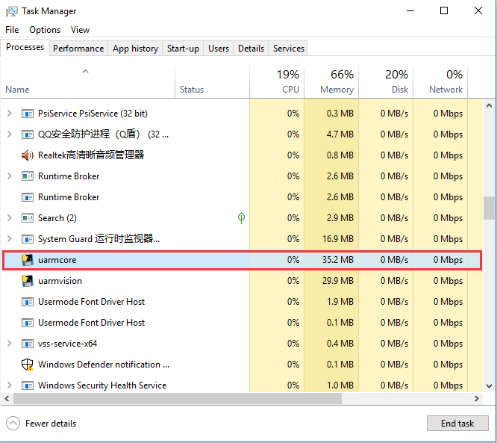

Q: How to download a single file from Github?

A: Please refer to the following [link](https://github.com/uArm-Developer/SwiftProForArduino/wiki/How-to-download-single-file-from-GitHub).